Application for Care at Premier Family Chiropractic

Today’s Date: ______________________________________ HRN: ____________

Personal Information

Name _____________________________________________ Date of Birth ____________
Gender: ▢ M ▢ F
Home Address __________________________________________ City _____________ State ____________ Zip ___________
Cell Phone ____________________________ Home Phone _______________________
Email Address ________________________________________________________________
Occupation __________________________________ Employer ____________________
Marital Status: ▢Single ▢Married ▢Divorced ▢Widowed
Spouse’s Name _______________________________________________________________
Number of Children & Ages: ___________________________________________________
Emergency Contact: Name ___________________________ Relationship ____________
Emergency Contact Phone Number ______________________________________________

Reason for Seeking Chiropractic Care
Please identify the reasons that brought you to this office:
Primary: _____________________________ Secondary: ___________________________
Third: _______________________________ Fourth: ______________________________
On a scale of 0 to 10 with 10 being the worst pain and 0 being no pain, rate the above reasons by marking the number:
Primary: Secondary:
▢ 0 ▢ 1 ▢ 2 ▢ 3 ▢ 4 ▢ 5 ▢ 6 ▢ 7 ▢ 8 ▢ 9 ▢ 10 ▢ 0 ▢ 1 ▢ 2 ▢ 3 ▢ 4 ▢ 5 ▢ 6 ▢ 7 ▢ 8 ▢ 9 ▢ 10
Third: Fourth:
▢ 0 ▢ 1 ▢ 2 ▢ 3 ▢ 4 ▢ 5 ▢ 6 ▢ 7 ▢ 8 ▢ 9 ▢ 10 ▢ 0 ▢ 1 ▢ 2 ▢ 3 ▢ 4 ▢ 5 ▢ 6 ▢ 7 ▢ 8 ▢ 9 ▢ 10
When did the problem(s) begin? ________________________________________________
When is the problem at its worst? ▢AM ▢PM ▢Mid-day ▢Constant ▢Comes & Goes
Have you suffered with this or a similar problem in the past? ▢ Yes ▢ No
How long does it last? _________________________________________________________
Is this related to an injury or accident? ▢ Yes ▢ No
If yes, please explain __________________________________________________________________
Has the problem ever been addressed by anyone in the past? ▢ Yes ▢ No
If yes, when? ______________________________ By whom? _______________________
How long were you under care? ________________________________________________
What were the results? _________________________________________________________
Name of Previous Chiropractor: _______________________________________ ▢ N/A
Please mark the areas on the diagram with the following legend to describe your symptoms:
Radiating Burning Dull Aching Sharp/Stabbing Tingling

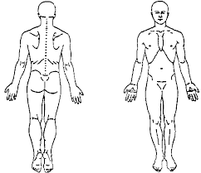
What relieves your symptoms? __________________________________________________
What makes them feel worse? ___________________________________________________

Activities of Daily Living/Symptoms/Medications
Daily Activities: Effects of current conditions on performance: Please identify how your current condition is affecting your ability to carry out activities that are routinely part of your life:

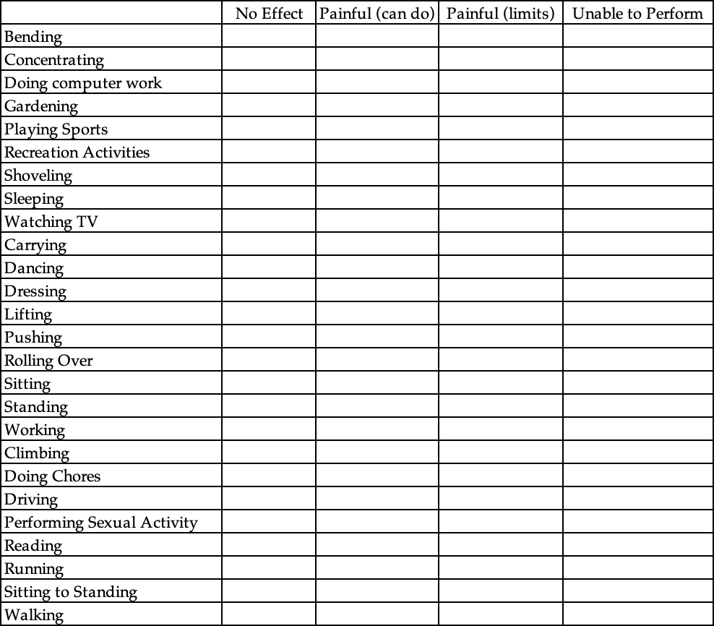

Other restricted activity that we should be aware of: _______________________________
______________________________________________________________________________
______________________________________________________________________________
Current Activity Level: ______________________________________________________________
_____________________________________________________________________________________
_____________________________________________________________________________________
Usual Activity Level: ________________________________________________________________
_____________________________________________________________________________________
_____________________________________________________________________________________

Physical Stress
Please identify any and all types of jobs you have had in the past that have imposed any physical stress on you or your body: _____________________________________________
_____________________________________________________________________________________
_____________________________________________________________________________________
Please list the major traumas, hospitalizations, surgeries, or injuries to your spine from your childhood to the present: __________________________________________________
_____________________________________________________________________________________
_____________________________________________________________________________________
Have you ever been involved in any high impact or contact-type sports (soccer, football, gymnastics, baseball, cheerleading, martial arts, etc.)? ▢ Yes ▢ No
If yes, please explain __________________________________________________________________
__________________________________________________________________________________________________________________________________________________________________________
How many hours do you sleep a night?
▢ Less than 5 hours ▢ 5-7 hours ▢ 7-9 hours ▢ More than 9 hours
Do you wake up: ▢ Refreshed ▢ Tired & Groggy
How many hours a day do you typically spend sitting at a desk or on a computer, tablet, or phone? ▢ 1 hour or less ▢ 2-4 hours ▢ 4-6 hours ▢ 8 or more hours

Emotional Stress
In your own words, please explain any areas of your life that you feel are causing you significant emotional stress (family, work, relationships, etc.) _______________________ _____________________________________________________________________________
_____________________________________________________________________________
Using the scale below, please grade each of the following areas in your life
0 - No stress 1 - A little stress 2 - Moderate stress 3 - A lot of stress 4 - Extreme stress
Regarding my life in general 0 1 2 3 4
Regarding my relationships 0 1 2 3 4
Regarding my finances 0 1 2 3 4
Regarding my work and career 0 1 2 3 4
Regarding my health and well-being 0 1 2 3 4
Regarding my time management skills 0 1 2 3 4

Chemical Stress
Do you presently consume any of the following?
▢ Artificial Sweetener ▢ Caffeine ▢ Dairy ▢ Gluten ▢Processed Foods Smoking: ▢ Cigars ▢ Pipe ▢ Cigarettes
How often? ▢ Daily ▢ Weekends ▢ Occasionally ▢ Never
Alcohol Consumption Occurs: ▢ Daily ▢ Weekends ▢ Occasionally ▢ Never
Recreational Drug Use: ▢ Daily ▢ Weekends ▢ Occasionally ▢ Never
List Prescription & Non-Prescription drugs you take:
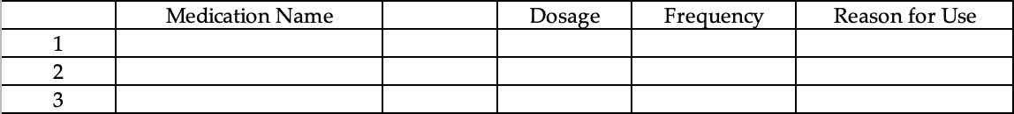
If you have ever been diagnosed with any of the following conditions, please mark with a P for the Past, C for Currently have or N for Never have had
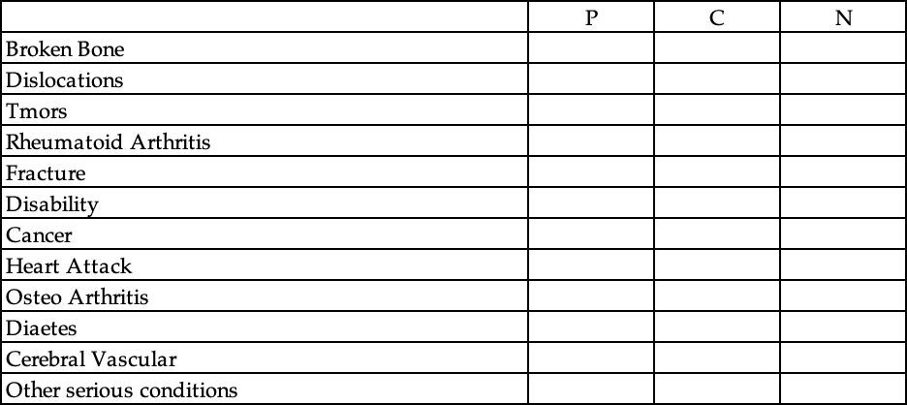
If other serious conditions, please specify: ________________________________________
______________________________________________________________________________
______________________________________________________________________________
Please mark P for past condition, Current for currently have and Never for never have experienced
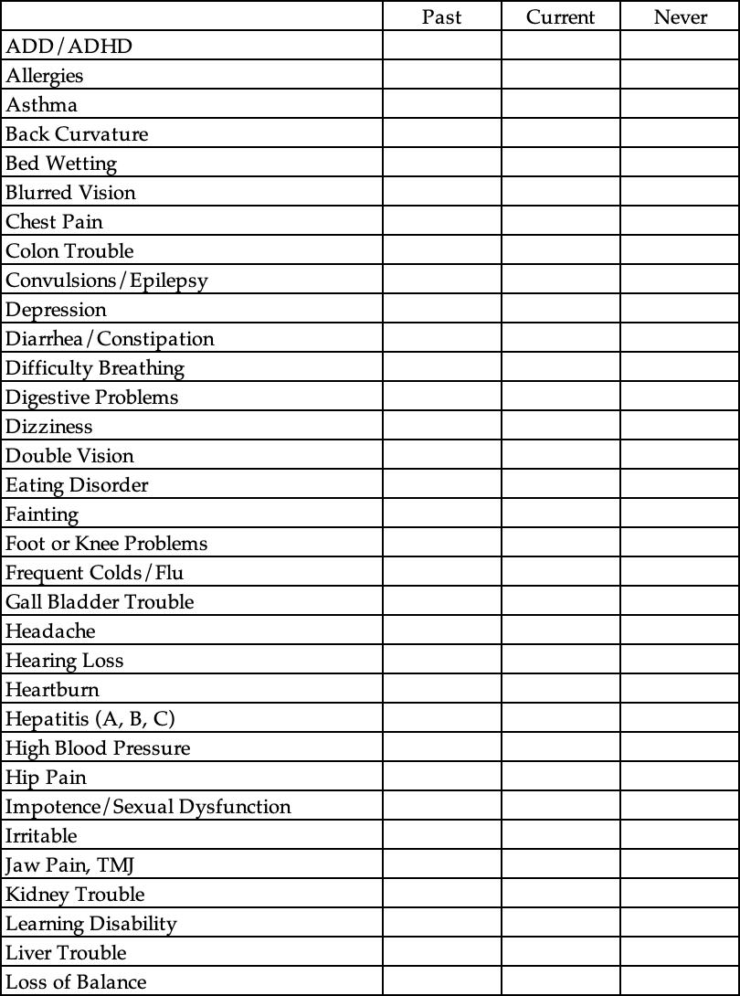

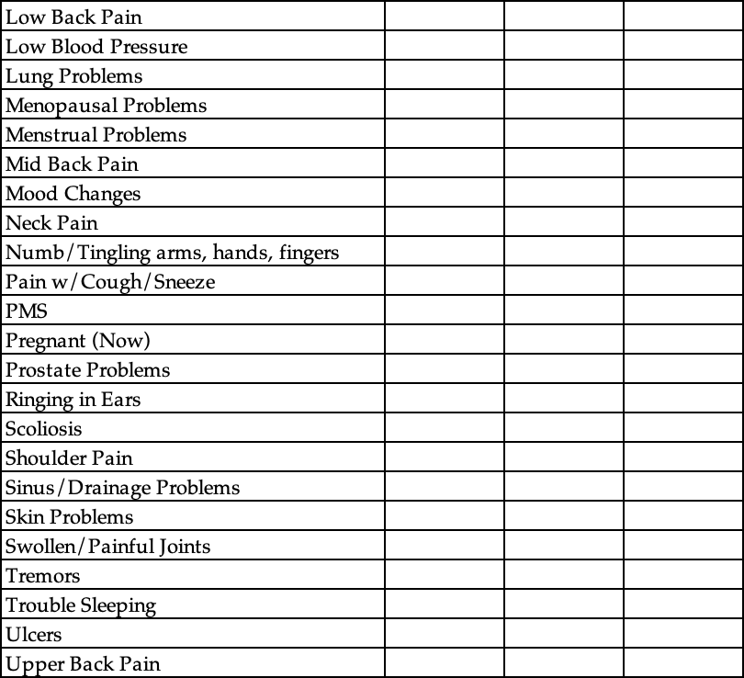

How did you hear about us? ____________________________________________________
______________________________________________________________________________
OUR OFFICE POLICIES
Premier Family Chiropractic

As a potential new patient, we feel it is important that you understand our office policies regarding how patients of this practice are cared for, and the various methods we offer to facilitate payment for that care. Please read each policy carefully so there is
no misunderstanding as to what you can expect as a patient of this practice, and what we expect in return. Once you have read “Our Office Policies”, if you have any questions or any of these policies are unclear to you, and you would like further
explanation, please let our front desk know and a member of our staff will be happy to discuss them with you further. We believe it is in everyone’s best interests to provide potential new patients as much information as possible about how the doctors at this
office practice chiropractic so that an informed decision can be made as to whether they wish to become a patient.

Over time, individuals who are accepted, as patients at this office, gain a greater understanding as to the purpose of chiropractic. Some of the care we provide occurs in an open bay area. This allows patients to observe the positive results that are achieved, and the benefits derived from being under chiropractic care. This knowledge and awareness reap a positive environment that promotes healing and encourages families to maintain good health. We want your experience with us to be an exceptional one, so help us to help you and together we can make affirmative changes in your life and the lives of those you care about.

REPORT OF FINDINGS
To enhance your understanding of the chiropractic approach that will be used to manage your health, immediately following your first adjustment, you will be scheduled for a ‘Doctors Report of Findings’. The information you receive at this appointment will be both informative and clinically relevant to your case, therefore attendance is required for individuals who wish to become new patients of this practice. Because the results of your x-rays and all examinations as well as the doctors’ recommendations for care, will be discussed at that time, we strongly urge new patients to invite their spouse or significant other to attend. We know from experience that when a patient’s family understands the goals and objectives of chiropractic care and how restoring and maintaining good health can affect their lives as well, they become infinitely supportive and helpful in making important decisions concerning treatment options.

NEW INJURIES
In the event you sustain a new injury, please let the front desk coordinator know as soon as possible. There may be additional paperwork to be filled out.

RESCHEDULING APPOINTMENTS
We set up specific treatment schedules for our patients. A certain number of treatments in a set amount of time are required for us to get the results we both desire. If you need to change this time, please reschedule your appointment for another time. If the same day is not possible, be sure to make up the missed appointment within one week.

PROGRESS EVALUATIONS
Progress evaluations & re-examinations will be performed periodically to determine your rate of progress and future course of treatment. A special time will be set up for your re-evaluation appointments.

PATIENT ACKNOWLEDGEMENT
I have read the above Office Policies. I acknowledge receiving a copy of the Office Policies. I further acknowledge that any concerns regarding these Office Policies as well as all my questions have been answered by a qualified member of the staff to my complete satisfaction.

Patient’s Name DOB HRN
____________________________________ ____________ ________________

Patient’s Signature Date
____________________________________ ____________

Witness
____________
Application for Care at
Premier Family Chiropractic

Informed Consent

REGARDING: Chiropractic Adjustments, Modalities, and Therapeutic Procedures:

I have been advised that chiropractic care, like all forms of health care, holds certain risks. While the risk are most often very minimal, in rare cases, complications such as sprain/strain injuries, irritation of a disc condition, and although rare, minor fractures, and possible stroke, which occurs at a rate between one instance per one million to one per two million, have been associated with chiropractic adjustments.

Treatment objectives as well as the risks associated with chiropractic adjustments and all other procedures provided at Premier Family Chiropractic have been explained to me to my satisfaction and I have conveyed my understanding of both to the doctor. After careful consideration, I do hereby consent to treatment by any means, method, and/or techniques, the doctor deems necessary to treat my condition at any time throughout the entire clinical course of my care.

___________________________________________________ ______________
Patient or Authorized person’s Signature Date

REGARDING: X-rays/Imaging Studies

FEMALES ONLY: please read carefully and check the boxes, include the appropriate date, then sign below if you understand and have no further questions, otherwise see our receptionist for further explanation.

▢ The first day of my last menstrual cycle was on ___________________

▢ I have been provided a full explanation of when I am most likely to become pregnant, and to the best of my knowledge, I am not pregnant.

By my signature below I am acknowledging that the doctor and or a member of the staff has discussed with me the hazardous effects of ionization to an unborn child, and I have conveyed my understanding of the risks associated with exposure to x-rays. After careful consideration I therefore, do hereby consent to have the diagnostic x-ray examination the doctor has deemed necessary in my case.

___________________________________________________ ______________
Patient or Authorized person’s Signature Date
Informed Consent

You are the decision maker for your health care. Part of our role is to provide you with information to assist you in making informed choices.

We may conduct some diagnostic or examination procedures if indicated. Any examinations or tests conducted will be carefully performed but may be uncomfortable.

Chiropractic care centrally involves what is known as a chiropractic adjustment. There may be additional supportive procedures or recommendations as well. Potential benefits of an adjustment include restoring normal joint motion, reducing swelling and inflammation in a joint, reducing pain in the joint, and improving neurological functioning and overall well-being.

It is important that you understand, as with all health care approaches, results are not guaranteed, and there is no promise to cure. As with all types of health care interventions, there are some risks to care, including, but not limited to: muscle spasms, aggravating and/or temporary increase in symptoms, lack of improvement of symptoms, burns and/or scarring from electrical stimulation and from hot or cold therapies, including but not limited to hot packs and ice, fractures (broken bones), disc injuries, strokes, dislocations, strains, and sprains.

With respect to strokes, there is a rare but serious condition known as an “arterial dissection” that typically is caused by a tear in the inner layer of the artery that may cause the development of a thrombus (clot) with the potential to lead to a stroke. The best available scientific evidence supports the understanding that chiropractic adjustment does not cause a dissection in a normal, healthy artery. Disease processes, genetic disorders, medications, and vessel abnormalities may cause an artery to be more susceptible to dissection.

Arterial dissections occur in 3-4 of every 100,000 people whether they are receiving health care or not. Patients who experience this condition often, but not always, present to their medical doctor or chiropractor with neck pain and headache.

The reported association between chiropractic visits and stroke is exceedingly rare and is estimated to be related in one in one million to one in two million cervical adjustments. For comparison, the incidence of hospital admission attributed to aspirin use from major GI events of the entire (upper and lower) GI tract was 1219 events/ per one million persons/year and risk of death has been estimated as 104 per one million users.

It is also important that you understand there are treatment options available for your condition other than chiropractic procedures. These options may include, but are not limited to: self-administered care, over-the counter pain relievers, physical measures and rest, medical care with prescription drugs, physical therapy, bracing, injections, and surgery. Lastly, you have the right to a second opinion and to secure other opinions about your circumstances and health care as you see fit.

I have read, or have had read to me, the above consent. I appreciate that it is not possible to consider every possible complication to care. I have also had an opportunity to ask questions about its content, and by signing below, I agree with the current or future recommendation to receive chiropractic care as is deemed appropriate
for my circumstance. I intend this consent to cover the entire course of care from all providers in this office for my present condition and for any future condition(s) for which I seek chiropractic care from this office.

Patient Name: ____________________________ Signature: __________________________
Parent or Guardian: _______________________ Signature: __________________________
Witness Name: ___________________________ Signature: __________________________

NOTICE OF PRIVACY PRACTICES (HIPAA NOTICE)

This notice describes how information about you may be used and disclosed and how you can get access to this information. Please review it carefully.

Your Rights
When it comes to your health information, you have certain rights. This section explains your rights and some of our responsibilities to help you.
Get an electronic or paper copy of your medical record:
You can ask to see or get an electronic or paper copy of your medical record and other health information we have about you. Ask us how to do this. We will provide a copy or a summary of your health information, usually within 30 days of your request. We may charge a reasonable, cost-based fee.
Ask us to correct your medical record:
You can ask us to correct health information about you that you think is incorrect or incomplete. Ask us how to do this. We may say “no” to your request, but we’ll tell you why in writing within 60 days.
Request confidential communications:
You can ask us to contact you in a specific way (for example, home or office phone) or to send mail to a different address. We will say “yes” to all reasonable requests.
Ask us to limit what we use or share:
If you pay for a service or health care item out-of-packet in full, you can ask us not to share that information for the purpose of payment or our operations with your health insurer. We will say “yes” unless a law requires us to share that information. You can ask us not to use or share certain health information for treatment, payment, or our operations. We are not required to agree to your request, and we may say “no” if it would affect your care.
Get a list of those with whom we’ve shared information:
You can ask for a list (accounting) of the times we’ve shared your health information for six years prior to the date you ask, who we shared it with and why. We will include all the disclosures except for those about treatment, payment, and health care operations, and certain other disclosures (such as any you asked us to make). We’ll provide one accounting a year for free but will charge a reasonable, cost-based fee if you ask for
another one within 12 months.
Get a copy of this privacy notice:
You can ask for a paper copy of this notice at any time, even if you have agreed to receive the notice electronically, we will provide you with a paper copy promptly.
Choose someone to act for you:
If you have given someone medical power of attorney or if someone is your legal guardian, that person can exercise your rights and make choices about your health information. We will make sure the person has this authority and can act for you before we take any action.
File a complaint if you feel your rights are violated:
You can complain if you feel we have violated your rights by contacting us. You can file a complaint with the U.S. Department of Health and Human Services Office for Civil Rights by sending a letter to 200 Independence Avenue, S.W., Washington, D.C. 20201, calling 1-877-696-6775, or visiting www.hhs.gov/ocr/privacy/hipaa/complaints. We will not retaliate against you for filing a complaint.
Your Choices
For certain health information, you can tell us your choices about what we share. If you have a clear preference for how we share your information in the situations described below, talk to us. Tell us what you want us to do,
and we will follow your instructions.
In these cases, you have both the right and choice to tell us to:
Share information with your family, close friends, or others involved in your care. Share information in a disaster relief situation. Include your information in a hospital directory. If you are not able to tell us your preference, for example if you are unconscious, we may go ahead and share your information if we believe it is in your best interest. We may also share your information when needed to lessen a serious and imminent threat to health or safety.
In these cases we never share your information unless you give us written permission:
Marketing purposes. Sale of your information. Sharing of psychotherapy notes.

In the case of fundraising:
We may contact you for fundraising efforts, but you can tell us not to contact you again.
Our Uses and Disclosures
How do we typically use or share your health information? We typically use or share your health information in the following ways:
Treat you:
We can use your health information and share it with other professionals who are treating you. Example: A doctor treating you for an injury asks another doctor about your overall health condition.
Run our organization:
We can use and share your health information to run our practice, improve your care, and contact your when necessary. Example: We use health information about you to manage your treatment and services.
Bill for your services:
We can use and share your health information to bill and get payment from health plans or other entities. Example: We give information about you to your health insurance plan so it will pay for your services.
How else can we use or share your health information?
We are allowed or required to share your information in other ways – usually in ways that contribute to the public good, such as public health and research. We have to meet many conditions in the law before we can share your information for these purposes. For more information see:
www.hhs.gov/ocr/privacy/hipaa/understanding/consumers/index.html.
Help with public health and safety issues:
We can share health information about you for certain situations such as preventing disease, helping with product recalls, reporting adverse reactions to medications, reporting suspected abuse, neglect, or domestic violence, preventing or reducing a serious threat to anyone’s health or safety.
Do research:
We can use or share your information for health research.

Comply with the law:
We will share information about you if state or federal laws require it, including with the Department of Health and Human Services if it wants to see that we’re complying with federal privacy law.
Respond to organ and tissue donation requests:
We can share health information about you with organ procurement organizations.
Work with a medical examiner or funeral director:
We can share health information with a coroner, medical examiner, or funeral director when an individual dies.
Address workers’ compensation, law enforcement, and other government requests:
We can use or share health information about you for worker’s compensation claims, for law enforcement purposes or with a law enforcement official, with health oversight agencies for activities authorized by law, for special government functions such as military, national security, and presidential protective services.
Respond to lawsuits and legal actions:
We can share heath information about you in response to a court or administrative order, or in response to a subpoena.

Our Responsibilities
- We are required by law to maintain to privacy and security of your protected health information.
- We will let you know promptly if a breach occurs that may have compromised the privacy or security of your information.
- We must follow the duties and privacy practices described in this notice and give you a copy of it.
- We will not use or share your information other than as described here unless you tell us we can in writing. If you tell us we can, you may change your mind at any time. Let us know in writing if you change your mind.
- For more information see: www.hhs.gov/ocr/privacy/hipaa/understanding/consumers/noticepp.htm

Changes to the Terms of this Notice:
We can change the terms of this notice and the changes will apply to all information about you. The new notice will be available upon request.
PATIENT ACKNOWLEDGEMENT OF HIPAA NOTICE

Notice to Patient:
We are required to offer you a copy of our HIPAA notice which states how we may use and/or disclose your health information. Our HIPAA notice and office policies contain information regarding payment, health insurance, collections and other important information.

Additional Items:
1) May we confirm your appointments by email, text or phone?
▢ Yes ▢ No
2) May we leave a message on your answering device at home or cell phone?
▢ Yes ▢ No
3) May we discuss your condition with any members of your family?
▢ Yes ▢ No
If yes, provide names:

Patient Acknowledgement:
I acknowledge and agree to this office’s HIPAA notice. I acknowledge that I have reviewed the HIPAA notice and have the right to obtain a paper copy of the HIPAA notice. I acknowledge that I may refuse to sign this acknowledgment if I wish.

_________________________________ _________________________________
Patient Printed Name Patient Signature or Legal Representative

_________________________________ _________________________________
Date If legal representative, state relationship

FOR OFFICE USE ONLY:
We have made every effort to obtain written acknowledgment of receipt of our HIPAA notice from this patient, but it could not be obtained because:
___ the patient refused to sign
___ we were not able to communicate with the patient
___ due to an emergency situation it was not possible to obtain a signature
___ other (please provide details):

_________________________________ _________________________________
Name of Patient Name of Staff Member

_________________________________ _________________________________
Date Signature of Staff Member

I hereby authorize payment to be made directly to this office for all benefits which may be payable under a healthcare plan or from any other collateral sources. I authorize utilization of this application or copies thereof for the purpose of processing claims and effecting payments, and further acknowledge that this assignment of benefits does not in any way relieve me of payment liability and that I will remain financially responsible to this office for any and all services I receive at this office.

Patient or Authorized Person’s Signature Date
_________________________________________ __________________

Doctor’s Signature Date
_________________________________________ __________________

We exist to be a place where people can experience LOVE, HOPE, & RESTORATION of their God-given potential

For office use only
I have reviewed the above ADL & ROS Form with the above named patient:
Doctor’s Signature _____________________________________________________________

